Now let’s take a look at two species of frogs from different climates:

**Directions: Read each statement carefully. Answer the question in the space provided or perform the requested task.**

1. Look below at the Jumping Distance Performance Curves for a Tropical vs. Temperate frog.

At what high temperature is the tropical frog’s jumping performance zero? ________

At what high temperature is the temperate frog’s jumping performance zero? ________   
What does this indicate about the frog’s health at this temperature? _______________________

1. At 30°C, draw a straight vertical line that extends from the x-axis until it reaches the temperate frog performance curve. As you learned, the chytrid fungus cannot survive above 30°C. Shade the area of the frog’s performance curve where it is too hot for the chytrid fungus to grow.
2. Can the tropical frog survive at a temperature outside of the upper limit for the chytrid fungus? _________________________________________
3. What does this indicate about the tropical frog’s ability to fight infection? __________________ ___________________________________________________________________________________

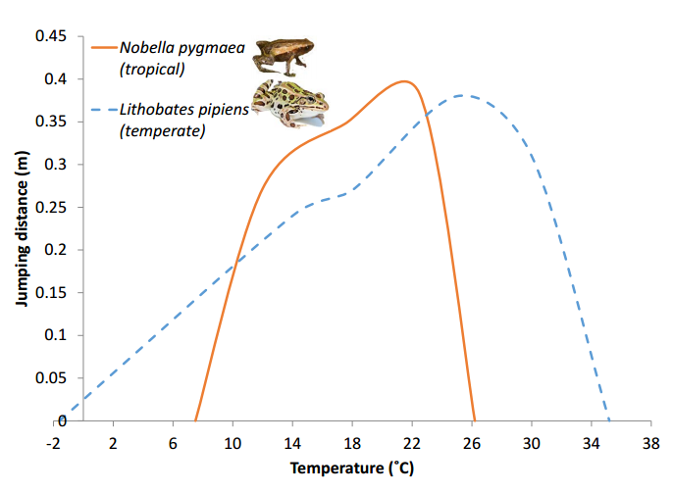How might climate change affect the relationship between the frog and the fungus? _________ ___________________________________________________________________________________ __________________________________________________________________________